**943987999**

Base URL:

|  |
| --- |
|  |

**Agreement URL:**

<http://zgnjhxb.niam.com.cn/EN/2095-5553/home.shtml>

* Select the issue from the issue list.

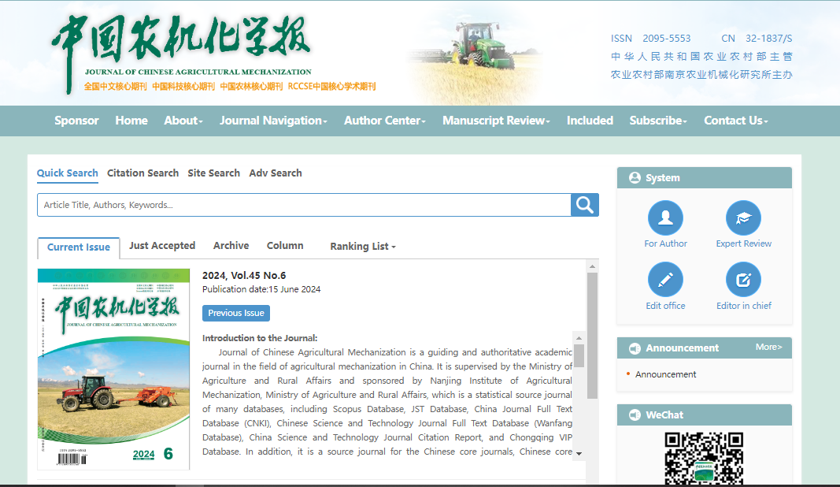

**Select the current issue from here.**

**Volume, issue**

**Publication Date**

* After selecting the issue content will appear here.

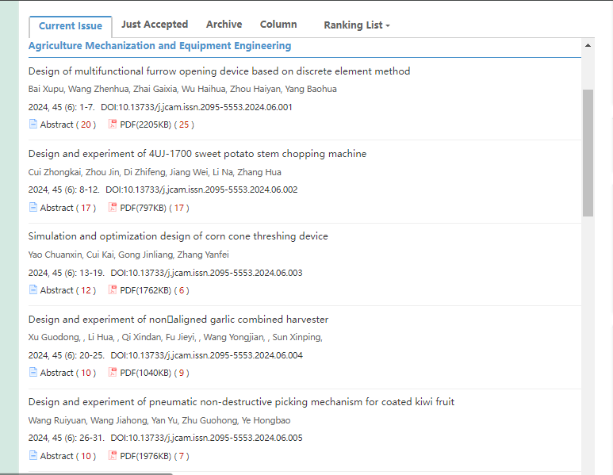

**Issue contents**

**Then click to the content one by one**

* All required articles will be listed here

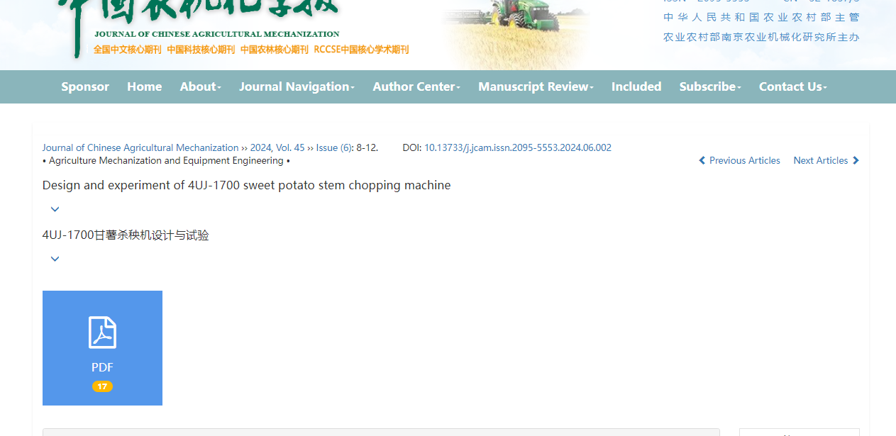

**Page range**

**Volume, issue**

**DOI**

**Title**

**Then click here to download the pdf**